J04. N.S.W. RAILWAYS SERIES. [1906]

Pu N.S.W. Railways
F Photogravure with title in lower margin ; back has impressed stamp (1d. red, State Arms)
There are at least two versions of the back - one (Steig type 5) has a stamp box, with impressed stamp below so that it falls roughly in the centre of the R.H. side (A) ; the second (Steig type 6) has no stamp box and the impressed stamp in the normal location (B). In the second of these, we also have two variants :
- the title running full width of the card (135mm.)
- title centred and only 110mm.

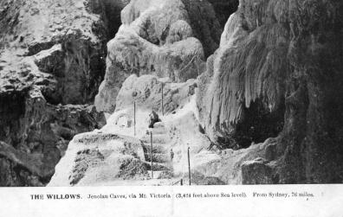
J04A.1 The Willows, Jenolan Caves, via Mt. Victoria (3,424 feet above Sea level) From Sydney, 76 miles. H

J04B.1a The Willows, Jenolan Caves, via Mt. Victoria (3,424 feet above Sea level) From Sydney, 76 miles. H
(with wide title and official use back - pm.12 Dec.1907)

J04B.1b SAME
(with narrow title and official use back - pm. 7 Nov.1908)

J04B.1c SAME
(with narrow title and plain back - pm. 18 July 1913)

